**Mockito Exercises**

**Exercise 1: Mocking and Stubbing**

* **Scenario:** We need to test a service that depends on an external API. Use Mockito to mock the external API and stub its methods.
* **ExternalApi.java**

* **MyService.java**

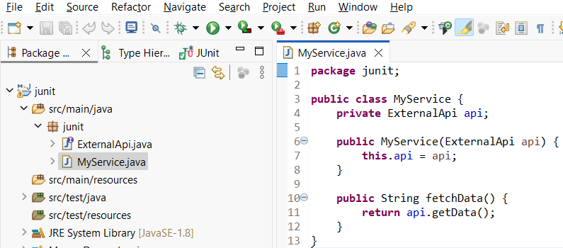

* **pom.xml**

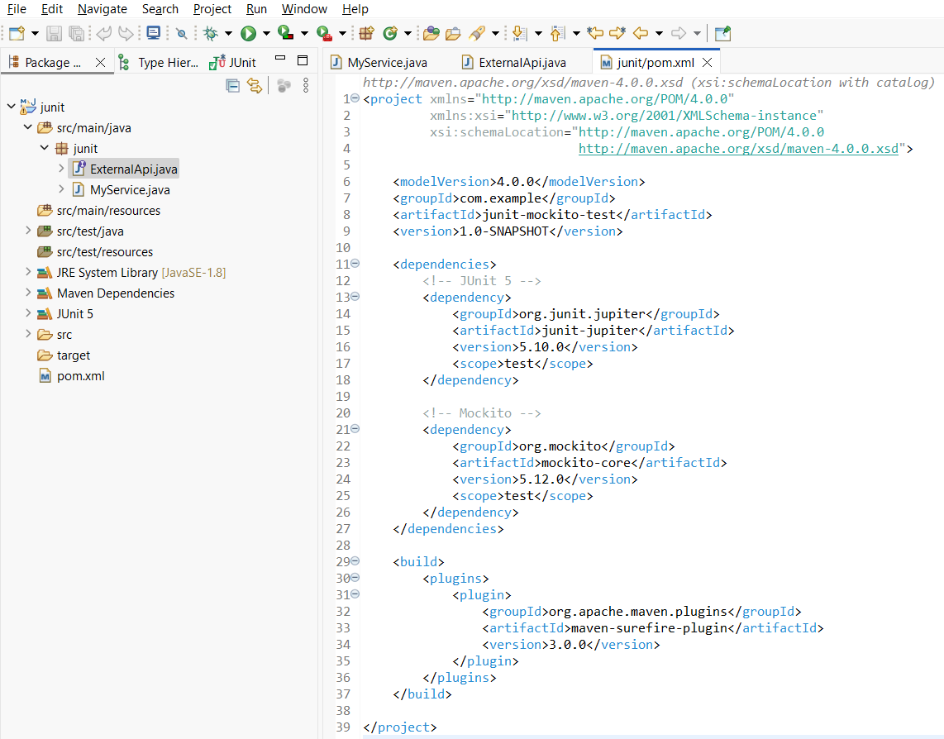

* **MyServiceTest.java**

* **Test Results (**Right click on **MyServiceTest.java -> Run As ->**

**JUnit Test)**

**Exercise 2: Verifying Interactions**

* **Scenario:** We need to ensure that a method is called with specific arguments.
* **ExternalApi.java**

* **MyService.java**

* **MyServiceTest.java**

* **pom.xml**

* **Test Results (**Right click on **MyServiceTest.java -> Run As ->**

**JUnit Test)**

